Documentation GradeBook

I.
Violation #1

1. Which SOLID principle is violated: Dependency Inversion Principle
2. Where in the code: Program.cs, line 3 - after builder.Services.AddControllers();, there was no DI registration for IItemReader.
3. Why it is a violation: The ItemController constructor asks for an IItemReader (an abstraction), but Program.cs never registered which concrete class implements it. Without this, ASP.NET doesn't know what object to provide, and the app crashes at runtime with: "Unable to resolve service for type 'IItemReader'". The abstraction and the implementation both existed, but they were never wired together.
4. The fix: Added builder.Services.AddScoped<IItemReader, ItemRepository>(); in Program.cs This makes ASP.NET know that when it is asked for IItemReader, provide an ItemRepository object with one instance per HTTP request.

Violation #2
1. Which SOLID principle is violated: Single Responsibility Principle
2. Where in the code: Controllers/ItemController.cs - lines 20, 28, 45, 49, 56 - all the Console.WriteLine() calls inside GetAll() and GetById() methods.
3. Why it is a violation: The controller is handling two responsibilities: managing HTTP requests and manually doing logging with Console.WriteLine(). Logging is a cross-cutting concern - it's not the controller's job. Also, Console.WriteLine is hardcoded to the console output; you can't red
4. The fix: Added ILogger<ItemController> as a second parameter in the constructor (ASP.NET Core provides it automatically through DI, no extra packages needed). Replaced all 5 Console.WriteLine() calls with _logger.LogInformation() or _logger.LogWarning(). Now logging is handled by the framework, and where the logs go (console, file, etc.) can be configured in appsettings.json.

Violation #3

1. Which SOLID principle is violated: Open/Closed Principle
2. Where in the code: Repositories/ItemRepository.cs - GetByIdAsync() line 13 (&& i.IsActive) and GetAllAsync() line 19 (.Where(i => i.IsActive)).
3. Why it is a violation: The repository had business filtering logic (IsActive) hardcoded inside it. The repository's job is just to access data and not modify it or validate it. This type of business decision should be put in the service layer so that if you need more filtering, you don’t have to modify the repository. The Open/Closed Principle says: classes should be open for extension but closed for modification.
4. The fix: Removed && i.IsActive from GetByIdAsync() and .Where(i => i.IsActive) from GetAllAsync(). The repository now returns all data without filtering. Business filtering (IsActive, passing grade, etc.) will be handled by the service layer). Changed protected fields to private and removed virtual keywords since subclassing isn't needed.

Violation #4

1. Which SOLID principle is violated: Dependency Inversion Principle
2. Where in the code: Controllers/ItemController.cs - line 10 (private readonly IItemReader _reader) and the constructor.
3. Why it is a violation: The controller was depended directly on the data layer, skipping any business logic layer. In a layered architecture, each layer should only depend to the one below it: Controller - Service - Repository. If the controller depends directly to the repository, there's nowhere to put business logic (filtering, calculations, validations) without adding it into the controller (which would violate SRP). The controller should depend on a service abstraction, not a data access abstraction.
4. The fix applied: Created a new IItemService interface (in Interfaces/IItemService.cs) and ItemService class (in Services/ItemService.cs). The service takes IItemReader (repository) in its constructor and delegates data access to it. Changed the controller to depend on IItemService instead of IItemReader. Registered IItemService in Program.cs with AddScoped. Now the flow is: Controller to Service to Repository.

After renaming the classes (Item->Grade), launchSettings launchUrl property needed updating also:
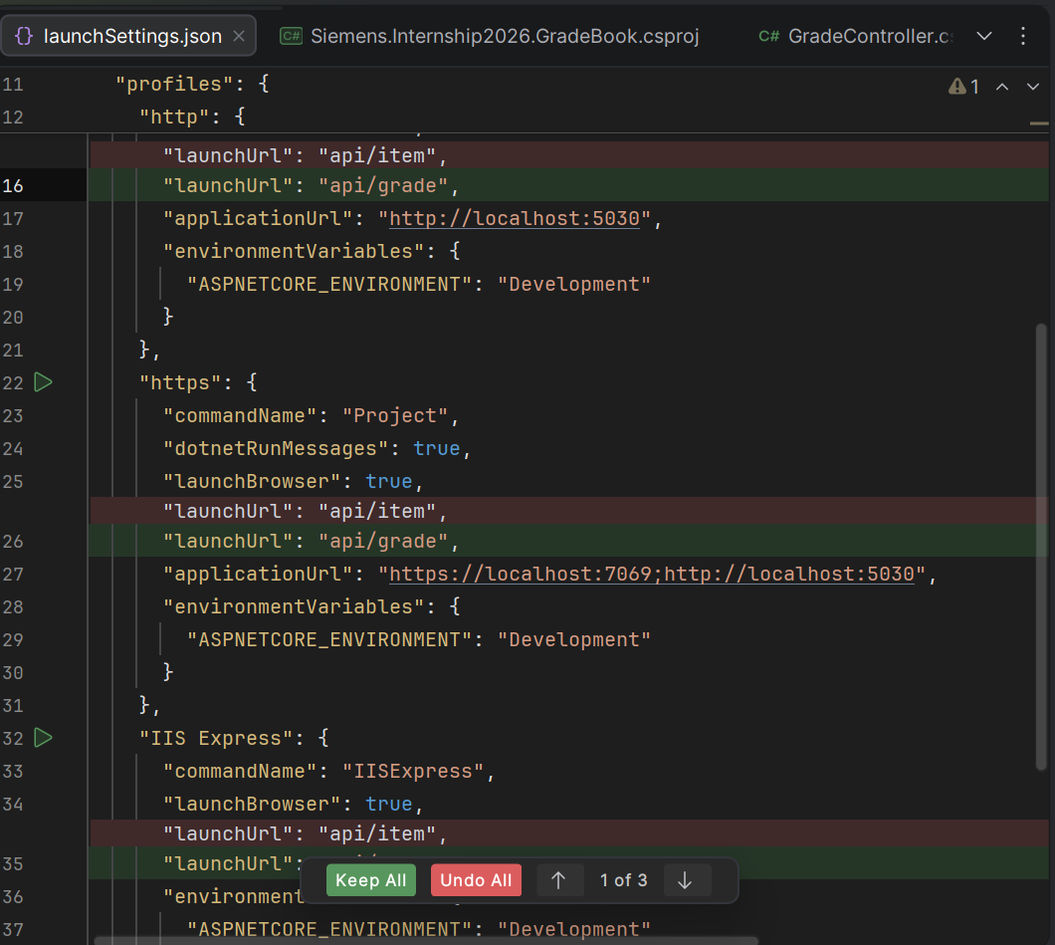

II. After updating from .NET8 to .NET10, checked that the change was really applied:
